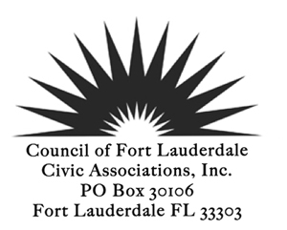
CFLCA General Membership Meeting Agenda
Tuesday, August 11, 2026
Meeting at Tower 101 aka the 101 Building
101 NE 3rd Avenue – 11th Floor Conference Room
Park in former City Hall Parking Lot – free after 4:00PM
Jets Pizza at 6:00PM
Meeting Starts at 6:30 PM

SPEAKERS and GUESTS
- Chris Cooper – Acting City Manager. City of Fort Lauderdale
- Aricka Johnson – Strategy and Innovation Manager, City of Fort Lauderdale
- Stefan Perritano – Chief Waterway Officer, City of Fort Lauderdale
- Steve Witten – Chairman of the Waterways and Marine Initiatives
Council Business –August 11th Meeting
- Business of the City – Chris Cooper
- Introduction of New Chief Waterways Officer – Stefan Perritano
- OMB Business Survey – Aricka Johnson
- Presentation on Waterways and Marine initiatives – Steve Whitten
- Approval of Meeting Minutes
- Membership Update
OLD BUSINESS
NEW BUSINESS
- District 1 Candidates Forum – September 23, 2026
- Grocery & Turkey Giveaway – November 21, 2026
FOR THE GOOD OF THE COMMUNITY
ADJOURN
*Indicates voting items or may be a voting item
Next Board Meeting August 24, 2026, via Zoom
Next General Membership Meeting September 08, 2026
Purpose: Focus on the issues relating to preservation of the present and future welfare of the City of Fort Lauderdale and its neighborhoods and citizens, be proactive and reactive to those issues, communicate any recommendations to the proper authorities, strive to improve communication and create a stronger partnership between City Government and the neighborhoods.

For More Information: https://cflca.org

