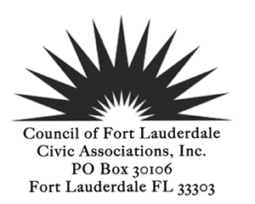

CFLCA wants to highlight your neighborhood at an upcoming General Meeting! We would love to learn what is unique and special about your neighborhood. Share with us the top priorities of your neighborhood and even your recent successes! We are excited to get to know you.
One lucky neighborhood will be randomly selected monthly to introduce themselves and their neighborhood at an upcoming General Meeting.
Just fill out the nomination form and email it to councilcorrespsec@gmail.com.

CLFCA Nomination Celebrate Success Form:
Date:________________________________

Association Name: ________________________________________________

Association President:___________________________________________

Nominating Person/persons:__________________________________

Self-Nominate: __________________________________________________

Email & Phone #_____________________________________________________________

Describe your neighborhood in 300 words or less (location, # residents, how old is your neighborhood)
_____________________________________________________________________________________
__________________________________________________________________________________________________________________________________________________________________________

What recent success does your Association have to celebrate? ____________________________________________________________________________________

_____________________________________________________________________________________

What pros/cons is your neighborhood currently facing? _________________________________________
_____________________________________________________________________________________.

Winners will be showcased in the Council Corner Newsletter & Featured at an Upcoming General Meeting

