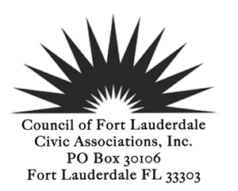

Please join CLFCA during our monthly meetings to CELEBRATE SUCESS. Has your association had a successful event or program? Whether its big or small we want to hear about it. Even if it had some small flaws, come and share your stories. Help your association be the best it can be. Successes will be acknowledged during our monthly meetings held the 2nd Tuesday of each month. Just fill out the nomination form and return to the above address or email it to CFLCApresident@gmail.com

Better yet bring your completed form to the next CLFCA meeting. We are looking forward to seeing you there and listening to your stories of success.

CLFCA Nomination Celebrate Success Form:
Date:________________________________

Association Name: ________________________________________________

Association President:___________________________________________

Nominating Person/persons:__________________________________

Self-Nominate: __________________________________________________

Email & Phone #_____________________________________________________________

Describe your success in 300 words or less
_____________________________________________________________________________________
__________________________________________________________________________________________________________________________________________________________________________

Please list the Cons if any________________________________________________________________

_____________________________________________________________________________________

How has your association benefited from this activity? _________________________________________
_____________________________________________________________________________________.

Would you be willing to share your success with other associations? _____Yes_____No

Winners will be showcased in the Council Corner Newsletter

