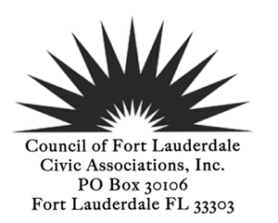
GENERAL MEMBERSHIP MEETING
June 10 2014 7:00 PM
8th floor Conference Room, City Hall
AGENDA
CALL TO ORDER 7:30 PM
PLEDGE of ALLEGIANCE
ROLL CALL
REVIEW AND ACCEPTANCE: May 14 2014 MEETING MINUTES *
TREASURER'S REPORT
POLICE/FIRE REPORT

ANNOUNCEMENTS/GUEST INTRODUCTIONS
Guest Speaker Mr. Robert Page Executive Director Crime Stoppers
Freddy ZeLaya Emergency Management Coordinator Demonstrating Hands Only CPR

REPORTS

Presidents Report
Membership Report
Committee Reports
Betty Shelly Education Advisory Board
School Board Needs Assessment for Fort Lauderdale Schools
Proposed $800 million dollar Broward School Bond
EAB Marketing efforts for Fort Lauderdale Schools
NEW BUSINESS
City Staff Presentation of Lauderserve Code Enforcement Reporting
City Staff Presentation of Adopt a Neighbor Helping Neighbors Keep Up Their Homes

OLD BUSINESS
Cancel the July 8 Meeting*

FOR THE GOOD OF THE COMMUNITY

ADJOURN

*Indicates voting items or may be a voting item
Next Board Meeting July 28 2014
Next General Membership Meeting August 12 2014

