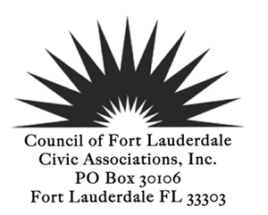
GENERAL MEMBERSHIP MEETING
April 8, 2014 7:00 PM
8th floor Conference Room, City Hall
AGENDA
CALL TO ORDER 7:30 PM
PLEDGE of ALLEGIANCE
ROLL CALL
REVIEW AND ACCEPTANCE: 1) MEETING MINUTES *
2) TREASURER’S REPORT
POLICE/FIRE REPORT

ANNOUNCEMENTS/GUEST INTRODUCTIONS
Diana Alarcon, Director of Transportation and Mobility,
Proposed Street Naming Policy

REPORTS
Presidents Report
Convention Center Expansion and Hotel Master Plan

Commission Prioritization/Goals Setting Workshop
Membership Report
Members for 2014 and Reps and Alts
Committee Reports
Legislative Committee Report on Vacation Rentals

NEW BUSINESS
Notice of vacancy for Recording Secretary, Call for Volunteers
and holding an Election in May to fill the vacancy
Oakland Park Article regarding intimidation of people at public meetings
Planning for Town Hall Meeting on Juvenile Issues

OLD BUSINESS
Guidelines for the Conduct of Public Hearings
Public Participation Ordinance
Dropping of Slap Suit against CBA

FOR THE GOOD OF THE COMMUNITY
Fleet Week April 28 to May 5

ADJOURN

*Indicates voting items or may be a voting item
Next Board Meeting April 28, 2014
Next General Membership Meeting May 13 2014

