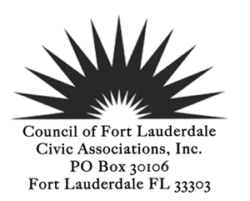
EXECUTIVE BOARD MEETING
October 28th, 2019 5:30 PM
Fort Lauderdale City Hall, 100 N Andrews Avenue, Fort Lauderdale, FL 33301
8th Floor Cafeteria
AGENDA
ROLL CALL
REVIEW AND ACCEPTANCE OF MINUTES Board Meeting 9_23_2019
TREASURER’S REPORT

REPORTS
Presidents Report
- Congrats on Betty’s birthday celebration
- Congrats on going green at GM
- November GM Agenda – Commissioner Ben Sorensen is a possibility

PRESENTATIONS

NEW BUSINESS
  - District Reports and Feedback – District Reps and Christina
  - Paypal, online banking and membership process – Stan and Brucie
  - Comp plan feedback final review
  - Promotion of summarized City Commission meetings (Lauderbrief) beyond CFLCA website posting - https://www.fortlauderdale.gov/Home/Components/News/News/3855/16?backlist=/home
  - Proposed ILA w/ BMPO Update: on 10/15/19 Ben Rogers gave a presentation to commission during workshop on the proposed ILA which covered some of what CFLCA requested. Materials available on the conference link for the 15th.
  - Holiday Party Reminder: 12/10/19 530 PARTY 630 MEETING START (Deb. Turkey/Ham & refreshments) Invite needs to go out to City people/Save the Date to Membership.

OLD BUSINESS

  - Don’t forget Day of the Dead!

November GM AGENDA – History/Other Speakers:

- Patrick Shavloske, Chief Executive Officer of Bonnet House Museum & Gardens
- Patricia Zeiler, Executive Director, Fort Lauderdale Historical Society

FOR THE GOOD OF THE COMMUNITY

ADJOURN
*Indicates voting items or may be a voting item
Next BOD Meeting November 25th, 2019
Next General Membership Meeting November 12th, 2019

