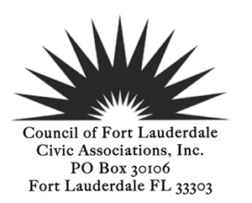
GENERAL MEMBERSHIP MEETING
September 11, 2018 6:30 PM
8th floor Commission Conference Room, City Hall
AGENDA
PLEDGE of ALLEGIANCE
ROLL CALL
REVIEW AND ACCEPTANCE: Approve the minutes of Aug 14 2018*
TREASURER’S REPORT
POLICE/FIRE REPORT
Honoring First Responders on 9/11:
- Fort Lauderdale Fire Chief Rhoda Mae Kerr
- Broward County Public Schools Fire Chief MaryAnn May

INTRODUCTION OF GUESTS
Greg Stuart, Director Broward MPO
Christopher Restrepo, Principal Planner
Introduction of the One-Way Pair on Andrews and 3rd Avenue

REPORTS
Presidents Report
Next Stop Fort Lauderdale, TOD study
Membership Report
2018 Membership Roll Confirm Reps and Alts
Committee Report
Infrastructure Task Force

NEW BUSINESS
“Behind The Scenes” Experiences for CFLCA Members – 10/13/18 at MODS: Screening of Great Barrier Reef at the IMAX Theater, tour of Eureka! Science of Archimedes.
Flex Units will be on the October General Meeting agenda

OLD BUSINESS

FOR THE GOOD OF THE COMMUNITY
Fort Lauderdale Make a Difference Day October 27

ADJOURN

*Indicates voting items or may be a voting item
Next Board Meeting September 24 2018
Next General Membership Meeting October 9 2018

