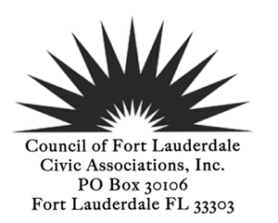
GENERAL MEMBERSHIP MEETING
January 13, 2015
8th floor Conference Room, City Hall
AGENDA
CALL TO ORDER 7:30 PM
PLEDGE of ALLEGIANCE
ROLL CALL
REVIEW AND ACCEPTANCE: Meeting Minutes of December 9, 2014*
TREASURER’S REPORT
POLICE/FIRE REPORT

ANNOUNCEMENTS/GUEST INTRODUCTIONS

The Vision Plan →The Strategic Plan→Capital Improvement Plan →You
Susanne Torriente, Assistant City Manager, Amy Knowles, Assistant to the City Manager, Jenni Morejon, Director of Sustainable Development, Hardeep Anand, Director of Public Works and Nancy Gassman Director of the Sustainability Division

REPORTS

Presidents Report
City Commission Workshop January 21
Support for the Education Advisory Board
Membership Report
Membership Renewal
Committee Reports
Nominating Committee Report

OLD BUSINESS
Neighbor Support Night February 12, 2015
Public Participation Ordinance
Registration for Recognized Civic Association Status

NEW BUSINESS
March Meeting with Broward County Commissioners

FOR THE GOOD OF THE COMMUNITY
Fort Lauderdale United Day/Martin Luther King Day January 19, 2015

ADJOURN
*Indicates voting items or may be a voting item
Next Board Meeting January 26, 2015
Next General Membership Meeting March 10, 2015

